
PT1/CSQP/1223/B 25-APR-2023
PERIODIC TEST - I (2023-2024)
Subject: Computer Science  Grade: XII |  | Max. Marks: 35  Time: 1 Hr 15 mins
General Instructions:
- This question paper contains three sections – A , B and C.
- Section A has 11 questions of 1 mark each.
- Section B has 9 questions carrying 2/3 marks each.
- Section C has 1 questions of 5 mark each.
- All programming questions are to be answered using Python Language only.
- Question paper contains 5 printed pages.
 | SECTION A
1 | Choose the correct command to delete an attribute A from a relation R.  (a) ALTER TABLE R DELETE A  (b) ALTER TABLE R DROP A  (c) ALTER TABLE DROP A FROM R  (d) DELETE A FROM |  | 1
2 | In the relational model, relationships among relations/table are created by using  _______ keys.  (a) composite  (b) alternate  (c) candidate  (d) foreign |  | 1
3 | Which of the following aggregate functions ignore NULL values?  (a) COUNT(*)  (b) MAX  (c) AVERAGE  (d) All of these |  | 1
4 | Which of the following is a DML command?  (a) SELECT  (b) ALTER  (c) CREATE  (d) DROP |  | 1
5 | For a table “Company” having column cno, cname, department and salary, write the SQL  statement to display average salary of each department. |  | 1
6 | Which constraint allows null value and no duplicate values?  - Group by  - Null  - Primary key  - Unique |  | 1
7 | What will be the output of the following code snippet?  dict = {}  dict[(1)] = 18  dict[(4)] = 10  dict[(1,3)] = 12  sum = 0  for k in dict:  sum += dict[k]  print (sum)  - 20  - 30  - 40  - 50 |  | 1
8 | Select the correct output of the code:  a = "EEPROM"  a = a.lstrip('E')  b = a[0] + "%" + str(len(a)) + "%" + a[3] + "%"  print(b)  - P%4%M%  - E%6%R%  - E%5%O%  - P%4%O% |  | 1
9 | Which of the following statement(s) would give an error after executing the following code:  X=”EXAMINATION” # Statement 1  Y= (“A”,”B”,”C”) # Statement 2  Z= X+Y # Statement 3  print(X[5]+Y[1]) # Statement 4  X[2]+=2 # Statement 5  - Statement 3 and 5  - Statement 4 and 5  - Statement 5  - Statement 3, 4 and 5 |  | 1
10 | What will the following expression be evaluated to in Python:  print(54/3+(3%12/2)*2)  - 21  - 21.0  - 18.0  - 18 |  | 1
11 | State True or False  “Python is a dynamically typed language.” |  | 1
 | SECTION -B
12 | Write outputs of SQL queries i) to iv) based on the relations SALES and LOCATION given below:-  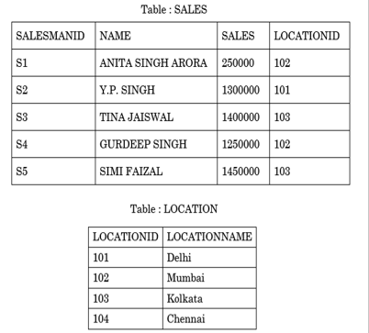  - SELECT LOCATIONID, AVG(SALES) FROM SALES GROUP BY LOCATIONID;  - SELECT S.NAME, L.LOCATIONNAME FROM SALES S , LOCATION L WHERE  S.LOCATIONID=L.LOCATIONID AND L.LOCATIONID=104;  - SELECT MAX(SALES) , MIN(SALES) FROM SALES;  - SELECT S.NAME, L.LOCATIONNAME FROM SALES S , LOCATION L WHERE  S.LOCATIONID=L.LOCATIONID AND S.SALES > 1400000; |  | 2
13 | Write the output for SQL queries (i) to (iv), which are based on the table: STUDENT  given below:  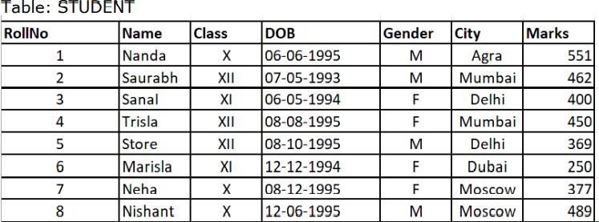  - SELECT COUNT(*), CITY FROM STUDENT GROUP BY CITY HAVING COUNT(*)>1  - SELECT SUM(MARKS)FROM STUDENT WHERE CITY =’Delhi’  - SELECT NAME, GENDER FROM STUDENT WHERE CITY=’Delhi’;  - SELECT DISTINCT Class from STUDENT; |  | 2
14 | Differentiate between count( col) and count(*) giving appropriate example. |  | 2
15 | 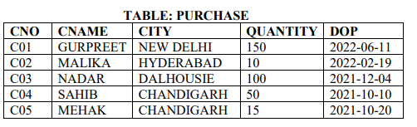  Consider the above table and answer the following questions  - Add a column Discount in the table with datatype as float.  - Assign discount as 10 percent of quantity for all rows. |  | 2
16 | Give the output of the below code.  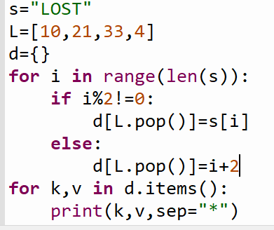 |  | 2
17 | Suhasini has written a Python code. Her code is having errors. Rewrite the correct code and underline the corrections made.  B=’ ‘  st=”2023”  x=st[2]+12  st[3]=x  print(st[5])  printf("New string is" , st) |  | 2
18 | - Given the Python string declaration:  Msg="DATAMINING-YEAR2022"  Write the output of : print(Msg[-4:10:-2])  - Write the output of the following code given below:  x = [12,67,'A',4]  d = ('W','6',7,2,'A')  x.append(x[2]+d[1])  x.append(x[3]+d[2])  print(x) |  | 2
19 | Differentiate between having and where clause in SQL giving appropriate examples. |  | 2
20 | Write a program in python to shift all negative elements to left and positive elements to right without changing the order.  For example if the list is [10,-2.-8,5,3,-15,9,-1]  After shifting the list is [-2,-8,-15,-1,10,5,3,9] |  | 3
 | SECTION – C
21 | Consider the table MobileMaster  Based on the data given above answer the following questions:  - Identify the most appropriate column, which can be considered as Primary key and why?  - If two columns are added and 2 rows are deleted from the table result, what will be the new degree and cardinality of the above table?  - Write the statements to:  - Display all records where Price is between 5000 and 15000 and company name begins with R..  - Delete the record of mobiles having price less than 8000.  - Set M_id as Primary Key. |  | 5
  M_Id | M_Company | M_Name | M_Price | M_Mf_Date
  MB001 | Samsung | Galaxy | 13000 | 2014-02-12
  MB002 | Nokia | N1100 | 7500 | 2011-04-15
  MB003 | Realme | C35 | 12000 | 2021-11-20
  MB004 | Oppo | SelfieEx | 12500 | 2015-08-21

***

